|  |
| --- |
| **Punchh Integration Setup Instructions**  **for**  **Punchh Integration Service** |

Table of Contents

[1. Introduction 3](#_Toc390941432)

[2. Installing Punchh Integration Service (PIS) on Linux 4](#_Toc390941433)

[2.1. Ubuntu 10.04 4](#_Toc390941434)

[2.1.1. Edit ‘/etc/apt/sources.list’ 4](#_Toc390941435)

[2.1.2. Install the Mono framework 4](#_Toc390941436)

[2.1.3. Download trusted root certificates 4](#_Toc390941437)

[2.1.4. Run the Punchh Integration Service 4](#_Toc390941438)

[2.1.5. Complete POS-specific steps provided by Punchh from separate documentation 4](#_Toc390941439)

[2.2. CentOS 6 4](#_Toc390941440)

[2.2.1. Install dependencies 4](#_Toc390941441)

[2.2.2. Download and unzip Mono framework source 4](#_Toc390941442)

[2.2.3. Compile and install Mono framework 4](#_Toc390941443)

[2.2.4. Download trusted root certificates 5](#_Toc390941444)

[2.2.5. Verify the Punchh Integration Service runs 5](#_Toc390941445)

[2.2.6. Setup the Punchh Integration Service to start automatically 5](#_Toc390941446)

[3. Installing Punchh Integration Service on Windows 6](#_Toc390941447)

[3.1. Execute the SetupPunchh.msi installer 6](#_Toc390941448)

[4. Advanced Configuration Options 8](#_Toc390941449)

[4.1. Enabling & Disabling Punchh Barcode Generation 8](#_Toc390941450)

[4.1.1. Disabling Punchh Barcode Generation 8](#_Toc390941451)

[4.1.2. Enabling Punchh Barcode Generation 9](#_Toc390941452)

[4.2. Enabling & Disabling Punchh Receipt Messages 9](#_Toc390941453)

[4.2.1. Verification of the Enabled Punchh Receipt Messages 9](#_Toc390941454)

[4.2.2. Editing/Adding a Receipt Message 11](#_Toc390941455)

[4.3. Disabling the Punchh Receipt Messages 12](#_Toc390941456)

[4.3.1. Verification of the existing Punchh Receipt Messages 12](#_Toc390941457)

[4.3.2. Disable Punchh Receipt Messages 13](#_Toc390941458)

# Introduction

Punchh **Point of Sales** (**POS**) Integration is done via a proxy web service, which is running on a local network. POS can talk to the service either via HTTP POST calls or via direct socket calls. Proxy service forwards calls to the Punchh backend and takes care of logging, heartbeat and queuing the data in case of network outages.

POS Integration is done differently for each POS system, but there is common component that has to be installed first. That is the **Punchh Integration Service** (PIS).

A purpose of this Instruction is to complete the **Punchh Integration Service** setup.

Typical scenario for all supported POS systems is as following:

1. Install PIS
2. Optionally (depends on the OS), install .Net 4.0. The PIS installer will prompt if needed.
3. Configure the PIS
4. Start (or restart) PIS.
5. Configure POS to talk to the PIS (POS-specific step)
6. Reboot the system
7. Verify the connection
8. Monitor data at the backend (“tail” and “grep” for the location ID)

# Installing Punchh Integration Service (PIS) on Linux

## Ubuntu 10.04

### Edit ‘/etc/apt/sources.list’

* Add the first line as shown below:

|  |
| --- |
| **sudo deb http://badgerports.org lucid main** |

### Install the Mono framework

|  |
| --- |
| **sudo apt-get install mono-complete** |

### Download trusted root certificates

|  |
| --- |
| **sudo mozroots --import --ask-remove** |

### Run the Punchh Integration Service

|  |
| --- |
| **cd /opt/punchh/Bin**  **sudo mono Punchh.exe –c** |

**\*NOTE:** The steps above were tested with Mono JIT compiler version 2.10.8.1 on Ubuntu 10.04.

### Complete POS-specific steps provided by Punchh from separate documentation

## CentOS 6

### Install dependencies

|  |
| --- |
| yum install bison gettext glib2 freetype fontconfig libpng libpng-devel libX11 libX11-devel glib2-devel libgdi\* libexif glibc-devel urw-fonts java unzip gcc gcc-c++ automake autoconf libtool make bzip2 wget  cd /usr/local/src |

### Download and unzip Mono framework source

|  |
| --- |
| wget http://download.mono-project.com/sources/mono/mono-3.0.1.tar.bz2  tar jxf mono-3.0.1.tar.bz2 |

### Compile and install Mono framework

|  |
| --- |
| ./configure --prefix=/opt/mono  make && make install |

### Download trusted root certificates

|  |
| --- |
| /opt/mono/bin/mozroots --import --ask-remove |

### Verify the Punchh Integration Service runs

1. For verification, run the command below:

|  |
| --- |
| **mono punchh.exe –c** |

1. Make sure no errors are reported on the console
2. Kill the application by pressing **Ctrl+C**

### Setup the Punchh Integration Service to start automatically

1. Edit **rc.local**

* Open the rc.local for editing:

|  |
| --- |
| **nano /etc/rc.d/rc.local** |

* Add the following line at the end of the file:

|  |
| --- |
| **/opt/mono/bin/mono /opt/punchh/Punchh.exe -c "$@" &** |

* Save the changes by with **Ctrl+X**
* Reboot the server by with **reboot**

1. Check the latest log in **/opt/punchh/Logs**, it should show the start up messages and no errors
2. Complete POS-specific steps from separate documentation

# Installing Punchh Integration Service on Windows

## Execute the SetupPunchh.msi installer

1. Login as an Administrator
2. Execute the **SetupPunchh.msi** installer

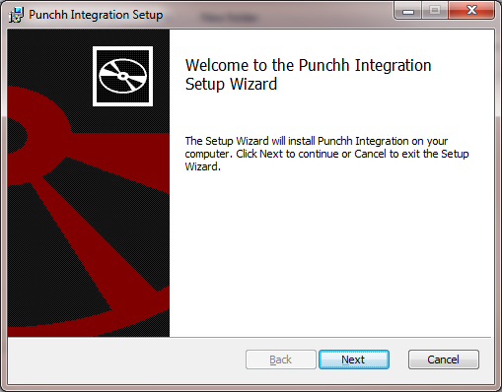 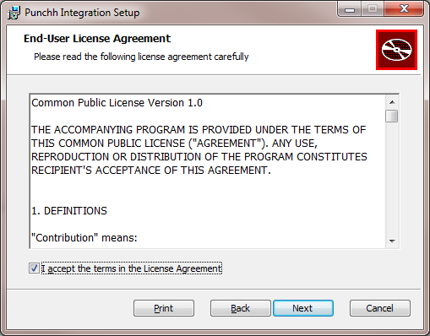

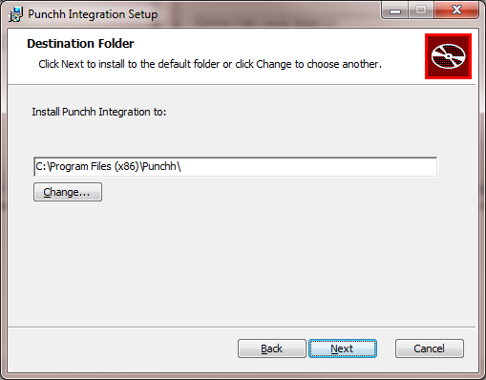 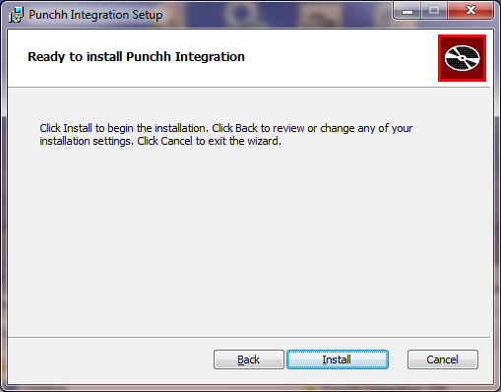

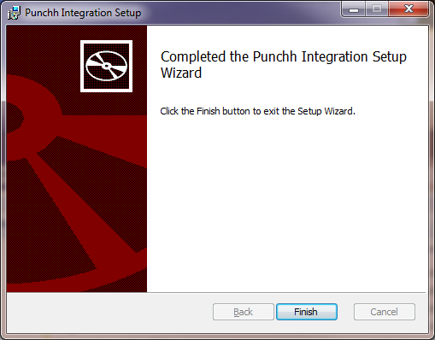

1. Hit the **Finish** button to close the *Punchh Integration Setup* window
2. Verify that the Punchh Installer has completed the following steps:

* Put the **PunchhConfigurator.exe** into the **Punchh** directory. For instance, "C:\Program Files (x86)\Punchh\Bin"
* Started the Punch service:

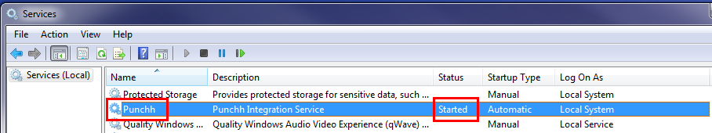

|  |
| --- |
| **\*NOTE:**  Setting up the “Punchh Integration” service is **NOT completed yet.**  There are a few more steps that must be completed for each particular POS on the file- and application level. Please see the ***POS-specific*** Punchh Integration Setup Instructions |

# Advanced Configuration Options

## Enabling & Disabling Punchh Barcode Generation

### Disabling Punchh Barcode Generation

By default, the Punchh Barcode Printing functionality is enabled. To make it disabled, please follow the steps below.

1. Open the Punchh.cfg file (for instance, *C:\Program Files (x86)\Punchh\Config\Punchh.cfg*) and verify that the “PrintBarcodes” string is marked as “**true**”: <PrintBarcodes>**true**</PrintBarcodes>
2. Navigate to the Punchh Locations page <https://punchh.com/locations>
3. Select your POS’ location, find and hit the **Edit** button. It will navigate you to the **Edit Location** screen:

D:\Vlad\Data_MyNotes\6.12.14 3.49.28 PM.png

1. On the **Edit Location** screen, update the following fields:

* Navigate to the **Validation Type** field and select the **Bar Code** item
* Navigate to the **POS Type** field and select your particular POS type

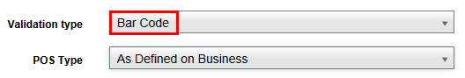

1. Navigate to the very bottom of the **Edit Location** screen and hit the “**Disable Barcode Generation at POS?**”button

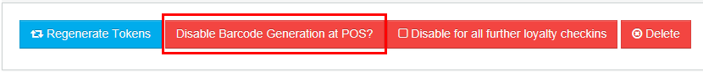

You should get the following changes:

1. The button at the very bottom of the **Edit Location** screen has to become green and change the label to “**Enable Barcode Generation at POS?**



1. Confirmation message on the top of the page:

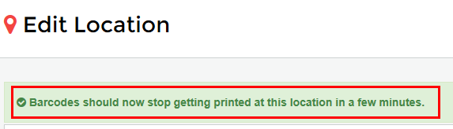

1. Wait for 2-3 minutes
2. Open the Punchh.cfg file and verify that the “PrintBarcodes” string is now marked as “false”: <PrintBarcodes>**false**</PrintBarcodes>

If the “PrintBarcodes” string is marked as “false” in the Punchh.cfg file, the Punchh barcode generation at POS is disabled, and the Punchh barcode is not printed on the receipt.

### Enabling Punchh Barcode Generation

1. Navigate to the very bottom of the **Edit Location** screen and hit the “**Enable Barcode Generation at POS?**”button



You should get the following changes:

1. The button at the very bottom of the **Edit Location** screen has to become red and change the label to “**Disable Barcode Generation at POS?”**



1. Confirmation message on the top of the page:

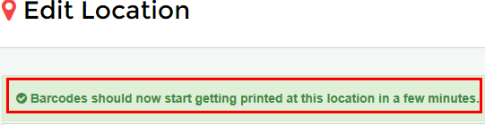

1. Wait for 2-3 minutes
2. Open the Punchh.cfg file and verify that the “PrintBarcodes” string is now marked as “false”: <PrintBarcodes>**true**</PrintBarcodes>

If the “PrintBarcodes” string is marked as “true” in the Punchh.cfg file, then the Punchh barcode generation at POS is enabled, and the Punchh barcode is printed on the receipt.

## Enabling & Disabling Punchh Receipt Messages

### Verification of the Enabled Punchh Receipt Messages

#### Verification in POS Application

1. Open your POS application, create an order, and submit the “**Pay Cash**” payment type.
2. Review the printed receipt with the Punchh barcode on it. For instance, message located below the Punchh barcode is this: “**Punchh greets you!”**

#### Verification on Punchh Website

1. Navigate to the **Punchh Locations** website: <https://punchh.com/locations>. You should be navigated to the **Businesses** screen
2. Find your POS on the **Businesses** screen. For instance, select **Sample Café**, and you should be navigated into the **Sample Café Dashboard** screen
3. Select the “**Setting**” -> “**Receipts Messages**” item on the Dashboard menu applet. You should be navigated to the “**Recept Messages**” screen.
4. On this screen, verify if you already have a message for this location. If yes, then navigate to the section associated with your particular location. For instance, let’s review the ***University Café*** location
5. Review the existing message. For the ***University Café*** location, let’s review the “**Punchh greets you!”** messge:

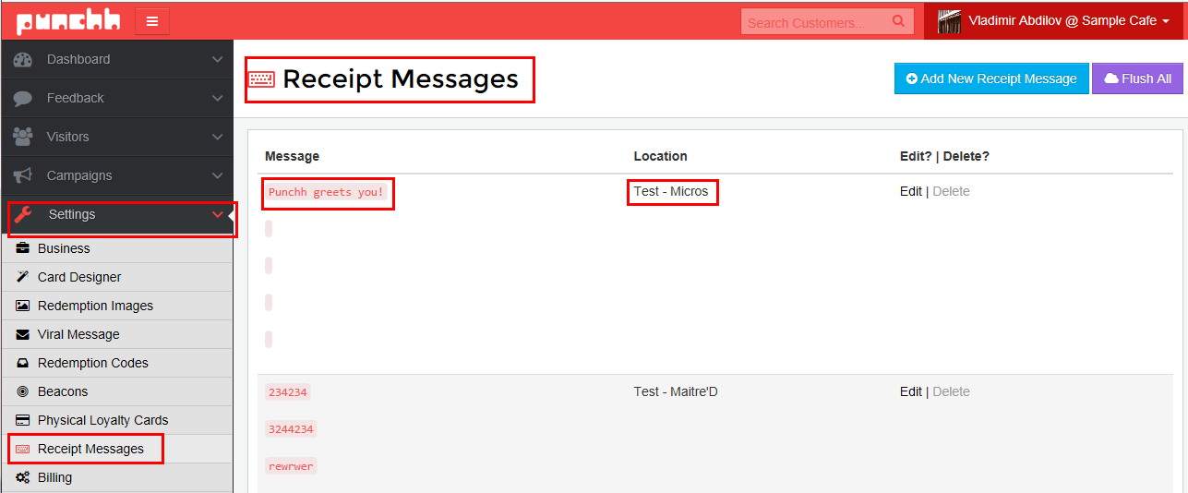 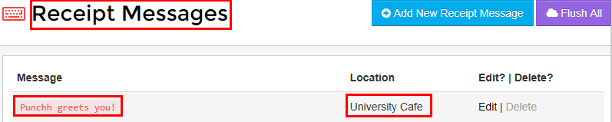

#### Verification Values in Punchh Configurator

Launch the provided **Punchh Configurator** utility that is already configured for your POS:

|  |
| --- |
| "C:\Program Files (x86)\Punchh\Bin\PunchhConfigurator.exe" |

You should be navigated to the **punchh.cfg** screen. Verify that the values in trailers are the same as it is currently on the Punchh website above:

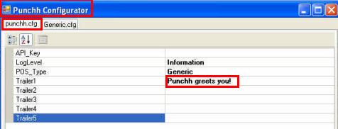

#### Verification Values in Punchh.cfg

1. Open the Micros application, create an order, and submit the “Pay Cash” payment type.
2. Review the printed receipt with the Punchh barcode on it. For instance, message below the barcode is this: “**Punchh greets you!”**
3. Open the "C:\Program Files (x86)\Punchh\Config\**Punchh.cfg**" file and look at the lines marked as <**Trailer**(X)>.

Notify what value exists in each trailer. For this example, the value must be “**Punchh greets you!”**:

\*\*\*\*\*\*\*\*\*\*\*\*\*\*\*\*\*\*\*\*\*\*\*\*\*\*\*\*\*\*\*\*\*\*\*\*\*\*\*\*\*\*\*\*\*\*\*\*\*\*\*\*\*\*\*\*\*\*\*\*\*\*\*\*\*\*\*\*\*\*\*\*\*\*\*\*\*\*\*\*\*\*\*\*\*\*\*\*\*\*\*\*\*\*\*\*

<PunchhConfig d1p1:type="PunchhConfig" xmlns:d1p1="http://www.w3.org/2001/XMLSchema-instance">

<POS>**[your POS]**</POS>

<LogLevel>4</LogLevel>

<API\_Key>**[Your POS API Key]**</API\_Key>

<Staging>false</Staging>

<PrintBarcodes>**true**</PrintBarcodes>

<Trailer1> **Punchh greets you!**</Trailer1>

<Trailer2 />

<Trailer3 />

<Trailer4 />

<Trailer5 />

</PunchhConfig>

\*\*\*\*\*\*\*\*\*\*\*\*\*\*\*\*\*\*\*\*\*\*\*\*\*\*\*\*\*\*\*\*\*\*\*\*\*\*\*\*\*\*\*\*\*\*\*\*\*\*\*\*\*\*\*\*\*\*\*\*\*\*\*\*\*\*\*\*\*\*\*\*\*\*\*\*\*\*\*\*\*\*\*\*\*\*\*\*\*\*\*\*\*\*\*\*

### Editing/Adding a Receipt Message

#### Editing/Adding Message Values on Punchh Website

On the **Recept Messages** screen, you can add a new message, or edit the existing ones.

**\*NOTE:** If you prefere to set a message for all locations, then make sure the **All Locations** option is selected for your new message.

For instance, to editing the existing record, please do the following:

 

1. Select the existing record “**Punchh greets you!”**, navigate to the “**Edit?|Delete?**” field, and hit the **Edit** hyperlink. The **Edit Receipt Message for [Your POS]** screen should pop up
2. On the **Edit Receipt Message for [Your POS]** screen, edit the “**Punchh greets you!”** value in the Barcode Message Line #1,and add a new message using the Barcode Message Line #2 field as it is shown below:

**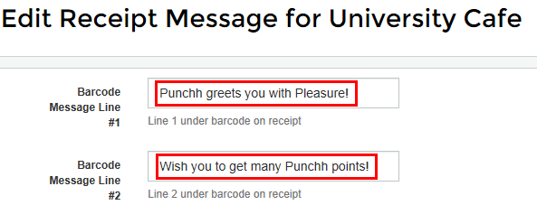**

****

1. Hit the **Save** button and get a confirmation:

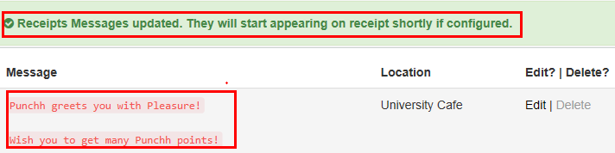

#### Verify Applied Changes in Punchh Configurator

Launch the provided **Punchh Configurator** utility:

|  |
| --- |
| "C:\Program Files (x86)\Punchh\Bin\PunchhConfigurator.exe" |

You should be navigated to the **punchh.cfg** screen. Verify that the values in trailers are updated per your changes you just applied via the Punchh website above.

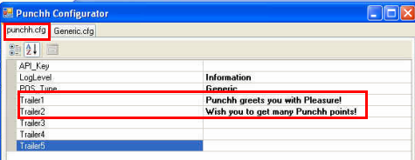

#### Verify Applied Changes in Punchh cfg

Open the "C:\Program Files (x86)\Punchh\Config\**Punchh.cfg**" file and look at the lines marked as <**Trailer**(X)>.

Notify what value exists in each trailer after applying the changes above. For this example, the value must be as following:

“**Punchh greets you with Pleasure!”**

“**Wish you to get many Punchh points!”**

\*\*\*\*\*\*\*\*\*\*\*\*\*\*\*\*\*\*\*\*\*\*\*\*\*\*\*\*\*\*\*\*\*\*\*\*\*\*\*\*\*\*\*\*\*\*\*\*\*\*\*\*\*\*\*

<PunchhConfig d1p1:type="PunchhConfig" xmlns:d1p1="http://www.w3.org/2001/XMLSchema-instance">

<POS>**[your POS]**</POS>

<LogLevel>4</LogLevel>

<API\_Key>**[Your POS API Key]**</API\_Key>

<Staging>false</Staging>

<PrintBarcodes>true</PrintBarcodes>

<Trailer1>**Punchh greets you with Pleasure!**</Trailer1>

<Trailer2>**Wish you to get many Punchh points!**</Trailer2>

<Trailer3 />

<Trailer4 />

<Trailer5 />

</PunchhConfig>

\*\*\*\*\*\*\*\*\*\*\*\*\*\*\*\*\*\*\*\*\*\*\*\*\*\*\*\*\*\*\*\*\*\*\*\*\*\*\*\*\*\*\*\*\*\*\*\*\*\*\*\*\*\*\*

#### Verify Applied Changes in POS Application

1. Open the Micros application, create an order, and submit the “**Pay Cash**” payment type.
2. Review the printed receipt with the Punchh barcode on it. For instance, messages below the barcode have to be like this:

“**Punchh greets you with Pleasure!”**

“**Wish you to get many Punchh points!”**

## Disabling the Punchh Receipt Messages

### Verification of the existing Punchh Receipt Messages

#### Punchh Locations website

1. Navigate to the “**Recept Messages**” screen on your POS **Dashboard** screen on the **Punchh Locations** website: <https://punchh.com/locations>.
2. On the “**Recept Messages**” screen, navigate to the section associated with your location
3. Review the existing messages. They must be the same as you set it up in the section above:

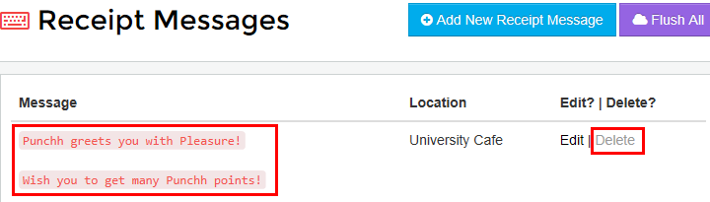

### Disable Punchh Receipt Messages

#### Disable Receipt Messages

1. On the “**Recept Messages**” screen, navigate to the section assosiated with your POS **Micros**
2. Hit the “**Delete”** hyperlink and make sure that the record was deleted successfully:



1. **wait for about 3-5 minutes.**

#### Verify Values in Punchh Configurator

* Launch the provided **Punchh Configurator** utility:

|  |
| --- |
| "C:\Program Files (x86)\Punchh\Bin\PunchhConfigurator.exe" |

* On the **punchh.cfg** screen, verify that there are **NO any values in any trailers.**

#### Verify Values in Punchh.cfg

Open the **Punchh.cfg** file and look at the lines marked as <**Trailer**(X)>.

Verify what value exists in each trailer. For this example, there should be **NO values**:

\*\*\*\*\*\*\*\*\*\*\*\*\*\*\*\*\*\*\*\*\*\*\*\*\*\*\*\*\*\*\*\*\*\*\*\*\*\*\*\*\*\*\*\*\*\*\*\*\*\*\*\*\*\*\*\*\*\*\*\*\*\*\*\*\*\*\*\*\*\*\*\*\*\*\*\*\*\*\*\*\*\*\*\*\*\*\*\*\*\*\*\*\*\*\*\*

<PunchhConfig d1p1:type="PunchhConfig" xmlns:d1p1="http://www.w3.org/2001/XMLSchema-instance">

<POS>**[your POS]**</POS>

<LogLevel>4</LogLevel>

<API\_Key>**[Your POS API Key]**</API\_Key>

<Staging>false</Staging>

<PrintBarcodes>true</PrintBarcodes>

<Trailer1 />

<Trailer2 />

<Trailer3 />

<Trailer4 />

<Trailer5 />

</PunchhConfig>

\*\*\*\*\*\*\*\*\*\*\*\*\*\*\*\*\*\*\*\*\*\*\*\*\*\*\*\*\*\*\*\*\*\*\*\*\*\*\*\*\*\*\*\*\*\*\*\*\*\*\*\*\*\*\*\*\*\*\*\*\*\*\*\*\*\*\*\*\*\*\*\*\*\*\*\*\*\*\*\*\*\*\*\*\*\*\*\*\*\*\*\*\*\*\*\*

#### Verify in POS Application

1. Open your POS application, create an order, and submit the “**Pay Cash**” payment type.
2. Review the printed receipt with the Punchh barcode on it. For this configuration, there should be **NO any Punchh messages** below the Punchh barcode.